NAME: VENKATRAMAMOORTHY.G
- Create a Weather App using react.
- Create a Calculator App using react.
CODE:
App.jsx
import { StrictMode } from 'react'
import { createRoot } from 'react-dom/client'
import './index.css'
import App from './App1.jsx'

createRoot(document.getElementById('root')).render(
<StrictMode>
<App />
</StrictMode>,
)
Weather.jsx
import { useState } from "react";
function Weather(){
const [city,setCity]=useState('');
const [temp,setTemp]=useState('');
const [weather,setWeather]=useState('');
const [a,setA]=useState(true);
async function handelapi(city){
let data=await fetch(`https://api.openweathermap.org/data/2.5/weather?q=${city}&appid=bd5e378503939ddaee76f12ad7a97608&units=metric`);
let result=await data.json();
let tem=result.main.temp;
let wea=result.weather[0].main;
setTemp(tem);
setWeather(wea);
setA(false);
}
function clear1(){
setCity('');
setTemp('');
setA(true)
}
return(
<>
<h1>Weather App</h1>
<input type="text" value={city} onChange={(e)=>setCity(e.target.value)}/><br/>
<button onClick={()=>handelapi(city)}>Search</button>
<button onClick={clear1}>clear</button>
<br/>
<h2 hidden={a}>{city} the temperature is {temp}°C Weather "{weather}"</h2>
</>
);
}
export default Weather;

OUTPUT:
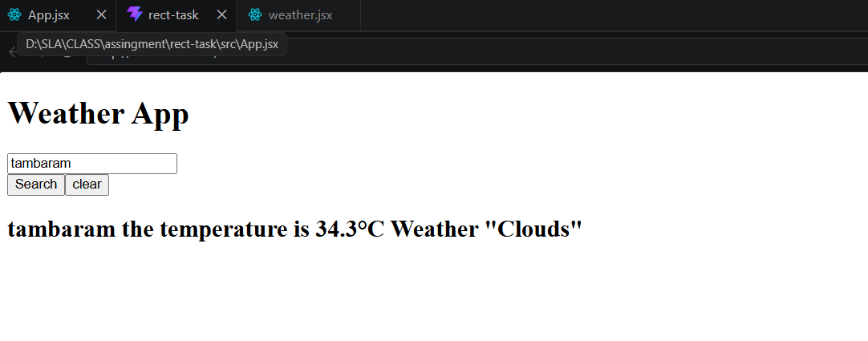
CODE:
App.jsx
import React, { useState } from "react";
import "./App.css";

function App() {
const [input, setInput] = useState("");

const handleClick = (value) => {
setInput(input + value);
};

const calculate = () => {
try {
setInput(eval(input).toString());
} catch {
setInput("Error");
}
};

const clearInput = () => {
setInput("");
};

return (
<div className="calculator">
<h1>Calculator</h1>

<input type="text" value={input} readOnly />

<div className="buttons">
<button onClick={() => handleClick("7")}>7</button>
<button onClick={() => handleClick("8")}>8</button>
<button onClick={() => handleClick("9")}>9</button>
<button onClick={() => handleClick("/")}>/</button>

<button onClick={() => handleClick("4")}>4</button>
<button onClick={() => handleClick("5")}>5</button>
<button onClick={() => handleClick("6")}>6</button>
<button onClick={() => handleClick("*")}>*</button>

<button onClick={() => handleClick("1")}>1</button>
<button onClick={() => handleClick("2")}>2</button>
<button onClick={() => handleClick("3")}>3</button>
<button onClick={() => handleClick("-")}>-</button>

<button onClick={() => handleClick("0")}>0</button>
<button onClick={() => handleClick(".")}>.</button>
<button onClick={calculate}>=</button>
<button onClick={() => handleClick("+")}>+</button>

<button className="clear" onClick={clearInput}>
C
</button>
</div>
</div>
);
}

export default App;
OUTPUT:
